Name = U.Siddhartha
Roll No = 2403A54122
Batch = 18
Set = A

Question No- 01
Write a Python code to calculate the sum of odd and even numbers in a given list using GitHub Copilot along with VS Code. Use zero shot prompting
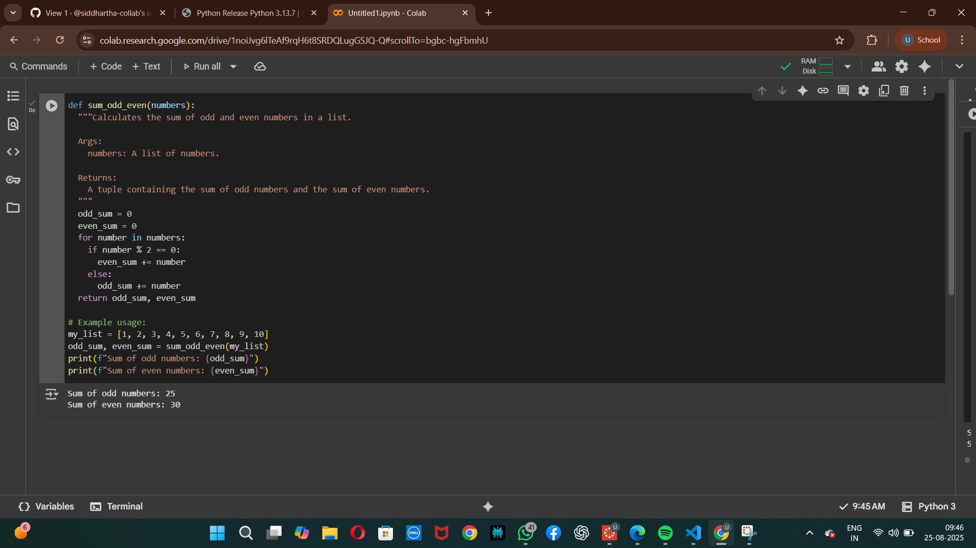
Question No – 02
Write a Python code for given a list of integers, remove duplicates and print the sorted result. GitHub Copilot along with VS Code. Use one shot prompting.
